**Assignment 5. Visualization UCs 12 Points**

**Team Assignment**

We discussed some of the challenges in developing the UCs for the following epic:

**Epic 3. (VisualizeCELDVData) As an AdminUser or a CELDVUser I can visualize CELDV data as directed graphs (digraphs) in one or more (virtual) display windows so I can navigate a graphic representation of the information in the CELDV data. (A picture is worth 1k words.)**

Develop and document 3 UCs that are part of this epic. Please choose “interesting UCs”. A UC that selects/identifies a node in the CELDV data may be essential to your visualization solution, but it’s not very interesting. Work on UCs that let the reader know how you are thinking about how your solution is determining the sub-digraphs of the CELDV data currently in the virtual CELDV display.

**UCs for Epic 3**

Epic 3. VisualizeCELDVData

As an AdminUser or a CELDVUser I can view CELDV data as directed graphs (digraphs) in one or more (virtual) display windows so I can navigate a graphic representation of the information in the CELDV data.

// List of types

CELDVUser

Employee

Employees

Employer

Employers

// Alternative Types – items that are not defined variables, they are inputs, or names for a button or display.

EmployeeSearchButton

EmployeeSearchPage

EmployerSearchButton

EmployerSearchPage

UserQuery

NoneFound digraph

UC 3.1 selectSearchType

As CELDVUser or AdminUser I can choose whether to query an Employer from Employers or an Employee from Employees

Required (EmployeeSearchButton, EmployerSearchButton, EmployeeSearchPage, EmployerSearchPage)

Case 1: If (EmployeeSearchButton is pressed) then

send CELDVUser to EmployeeSearchPage

Case 2: If (EmployerSearchButton is pressed) then

send CELDVUser to EmployerSearchPage

UC 3.2 searchEmployee (search bar)

As a CELDVUser or AdminUser I can search for any Employee to view their related digraph

Required (Employee, Employees, UserQuery)

Case 1: If (UserQuery is in Employees) then

return the employeeInformation equal to the UserQuery

Case 2: If (UserQuery is NOT in Employees) then

notify CELDVUser that the Employee could not be found

UC 3.3 viewEmployeeHistory

As a CELDVUser or AdminUser I can choose to view the Employee history of the selected Employee

Required (Employee, Employers, Employer, employers, EmployedInJob, NoneFound digraph)

Case 1: If (EmploymentHistory is pressed & employers has EmployedInJob) then

return EmployementHistory digraph

Case 2: If (EmployementHistory is pressed & employers has no EmployedInJob) then

return NoneFound digraph

UC 3.4 searchEmployer (search bar)

As a CELDVUser or AdminUser I can search for any Employer to view their related digraph

Required (Employer, Employers)

Case 1: If (UserQuery in Employers) then

return the Employer equal to the UserQuery

Case 2: If (UserQuery NOT in Employers) then

notify CELDVUser that Employer is not found

UC 3.5 viewCurrentEmployees  
 As a CELDVUser or AdminUser I want to view the list of currentEmployees at a Company.

Required (Employees, Employer)

Case 1: if (Employer is selected from searchEmployer) then

display employeeListPage

UC 3.6 viewEmployerDigraph

As a CELDVUser or AdminUser I want to be able to view the Employer Digraph of the selected Employer

Required(Employer, Employers, descendantCompanies, predecedantCompanies)

Case 1: if (viewDiagraph button is pressed) then

return Employer Digraph

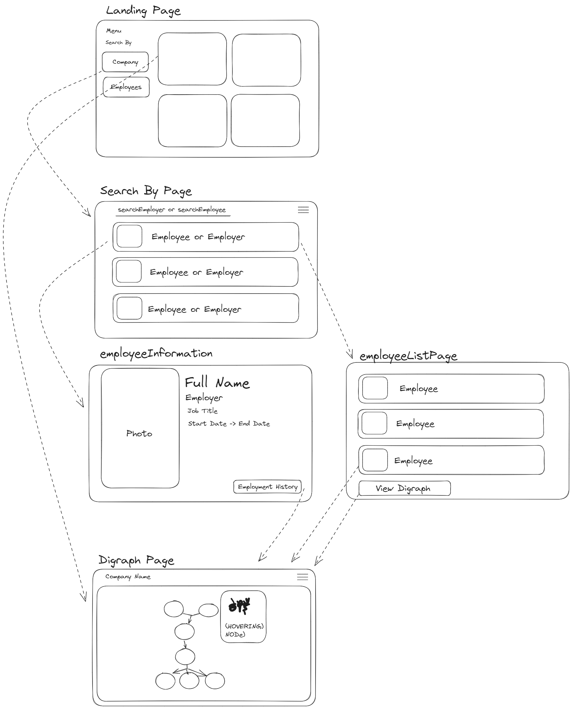

**Due Time/Date**

Your team is to be prepared to share and discuss your solution with the rest of the class on Tuesday 10/3/2023. You will then submit your solution (with any revisions resulting from the discussion in class on 10/3) by 9:00pm on 10/3. Please insert your ADM for the pertinent CELDV data in the submitted solution to provide the vocabulary you use in your UC specifications.

Submit one copy of your Vis

CPSC 4392 Fall23.5.Visualization UCs.The Catapillars.docx